CLASS-9/MATHS
CASE STUDY 1/Exchange Rate
Mei-Ling from Singapore was preparing to go to South Africa for 3 months as an exchange student. She needed to change some Singapore dollars (SGD) into South African rand (ZAR).
Q1.Mei-Ling found out that the exchange rate between Singapore dollars and South African rand was:
1 SGD = 4.2 ZAR .Mei-Ling changed 3000 Singapore dollars into South African rand at this exchange rate. How much money in South African rand did Mei-Ling get?
Q2. On returning to Singapore after 3 months, Mei-Ling had 3 900 ZAR left. She changed this back to Singapore dollars, noting that the exchange rate had changed to:1 SGD = 4.0 ZAR .How much money in Singapore dollars did Mei-Ling get?
Q3. During these 3 months the exchange rate had changed from 4.2 to 4.0 ZAR per SGD. Was it in Mei-Ling’s favour that the exchange rate now was 4.0 ZAR instead of 4.2 ZAR, when she changed her South African rand back to Singapore dollars? Give an explanation to support your answer.
CASE STUDY-2/Reaction Time
In a Sprinting event, the ‘reaction time’ is the time interval between the starter’s gun firing and the athlete leaving the starting block. The ‘final time’ includes both this reaction time, and the running time. The following table gives the reaction time and the final time of 8 runners in a 100 metre sprint race.
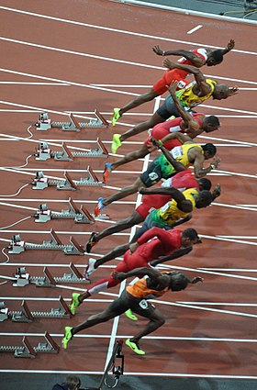

ANSWER THE QUESTIONS:
- To date, no humans have been able to react to a starter’s gun in less than 0.110 second. If the recorded reaction time for a runner is less than 0.110 second, then a false start is considered to have occurred because the runner must have left before hearing the gun.
If the Bronze medallist had a faster reaction time, would he have had a chance to win the Silver medal? Give an explanation to support your answer.

